**DATABASE ASSIGNMENT**

**CRIMES IN INDIA**

1.What is major reason people being kidnapped in each and every states?

SELECT innertab.Area_Name , innertab.Sub_Group_Name , innertab.female_total , innertab.male_total , max(total) as max_total FROM

(select Area_Name , Sub_Group_Name , sum(K_A_Female_Total) as female_total , sum(K_A_Male_Total) as male_total , sum(K_A_Grand_Total) as total from "39_Specific_purpose_of_kidnapping_and_abduction"

WHERE Sub_Group_Name NOT like "14. Total (Sum of 1-13 Above)"

GROUP by Area_Name , Sub_Group_Name) innertab

GROUP by Area_Name

ORDER by max_total DESC

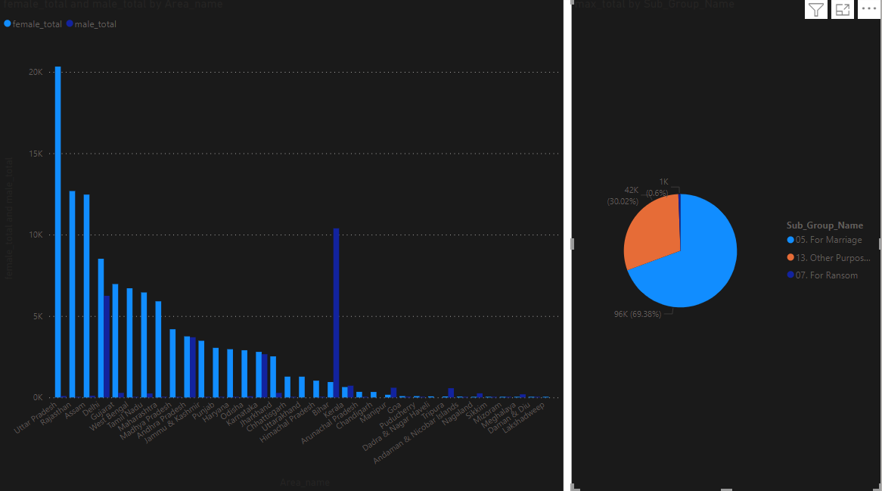

Observation :- from this we can observe that there are more number of kidnapped being done uttar Pradesh for the purpose of marriage.

This may be because of large population of males as comparision to female population. This huge difference is can be considered as the major reason of kidnap. Also we found out that there are very less number of kidnaps for ransom that means people their donot kidnap for money.

2.offenders relation to the rape victim?

SELECT Area_Name , sum(no_of_cases_in_which_offenders_were_neighbours) as neighbour , sum(no_of_cases_in_which_offenders_were_other_known_persons) as other_known_person ,

sum(No_of_Cases_in_which_offenders_were_Relatives) as relatives , sum(No_of_Cases_in_which_offenders_were_Parentsclose_family_members) as family_member FROM "Offenders_known"

GROUP by Area_Name

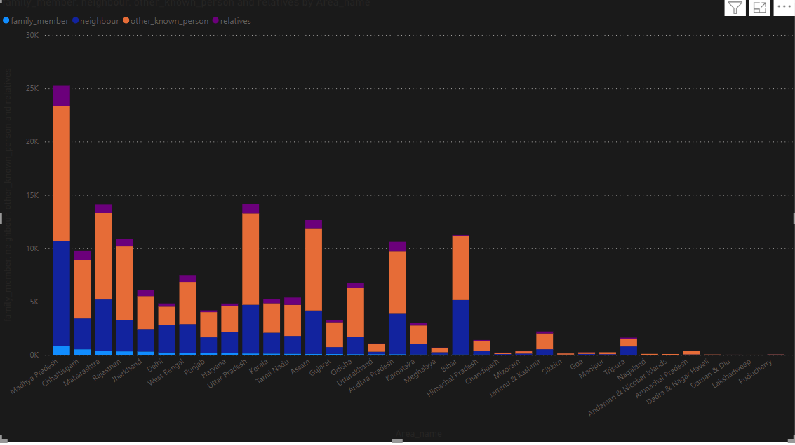

Observation :- we can see that there are more number of rape cases in Madhya Pradesh , maharastrya and uttar Pradesh and in all states one thing is common that most the cases can be seen that the offenders were the other known person and after that offenders were neighbour.

3.Juveniles family background , economisetup , education?

SELECT Economicsetup.Area_Name ,

sum(Economic_set_up_annual_income_upto_rs_25000) ,

sum(Economic_Set_up_Annual_Income_250001_to_50000) ,

sum(Economic_Set_up_Middle_income_from_50001_to_100000) ,

sum(Economic_Set_up_Middle_income_from_100001_to_200000) ,

sum(Economic_Set_up_Upper_middle_income_from_200001_to_300000) ,

sum(Economic_Set_up_Upper_income_above_Rs_300000) ,

sum(Family_back_ground_Homeless) ,

sum(Family_back_ground_Living_with_guardian) ,

sum(Family_back_ground_Living_with_parents) ,

sum(Education_Upto_primary) ,

sum(Education_Above_Primary_but_below_Matric_or_Higher_Secondary) ,

sum(Education_Illiterate) FROM "Economicsetup"

INNER JOIN "Familybackground"

on Economicsetup.Area_Name = Familybackground.Area_Name

INNER JOIN "Education"

on Familybackground.Area_Name = Education.Area_Name

group by Economicsetup.Area_Name

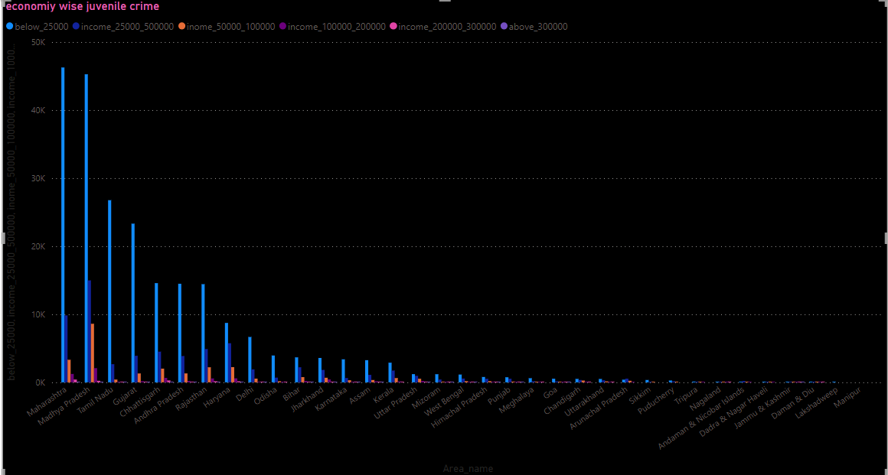

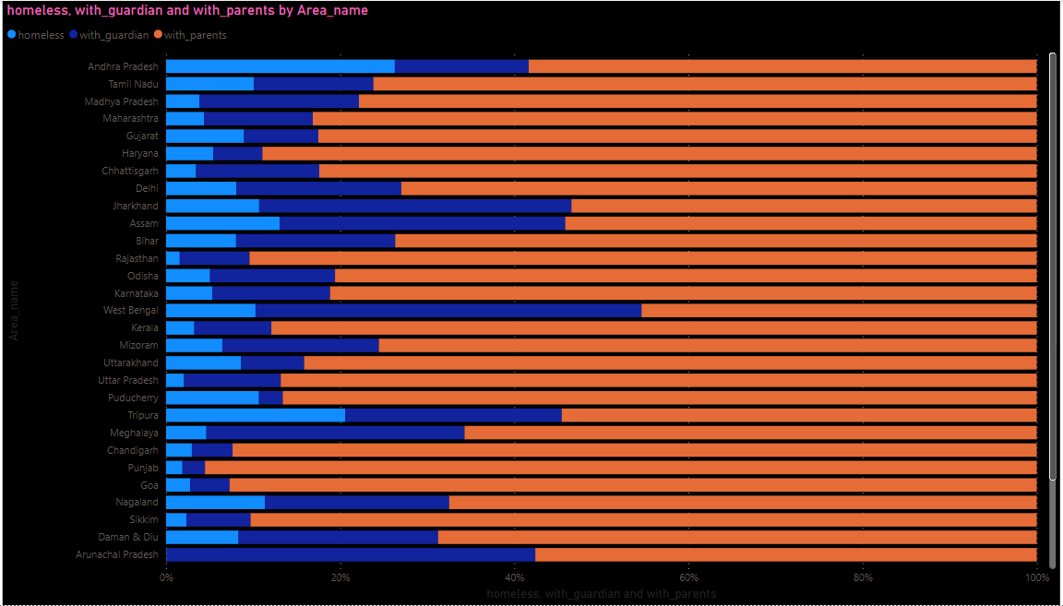

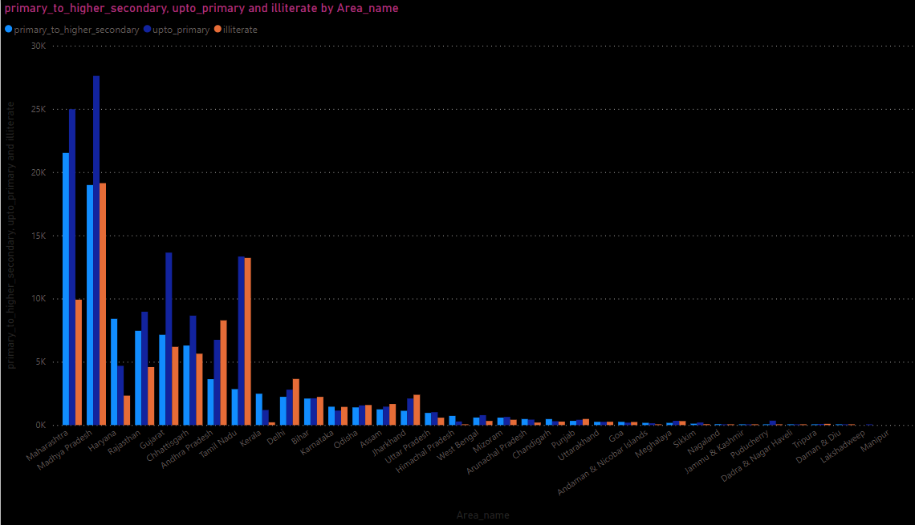

Observation:- here we have all the shocking result which are beyond anyone expectation. In juvenile crime we found out that most of the crime are being done by economically poor class people may be to run their livelihood or for any other reasons. Also we found out that juveniles who live their parents and who are in below primary education level they are more involved in crime. Despite of getting proper love and care from their parents. This is really the matter of concern that why these children are more involved in crime.

4.which state has more crime against children and women?

SELECT innertab.Area_Name , innertab.Sub_Group_Name , (innertab.below_ten + innertab.below_15 + innertab.below_18) as children_victim FROM

(SELECT Area_Name , Sub_Group_Name , sum(Victims_Upto_10_Yrs) as below_ten , sum(victims_upto_10_15_yrs) as below_15 , sum(victims_upto_15_18_yrs)as below_18 , sum(Victims_Total) as total_victim FROM "Murder_victim"

WHERE Sub_Group_Name like "3. Total"

GROUP by Area_Name , Sub_Group_Name) innertab

ORDER by children_victim DESC

SELECT Area_Name , Sub_Group_Name , sum(victims_total) as total_female_victims FROM "Murder_victim"

WHERE Sub_Group_Name like "2. Female Victims"

GROUP by Area_Name , Sub_Group_Name

ORDER by total_female_victims DESC

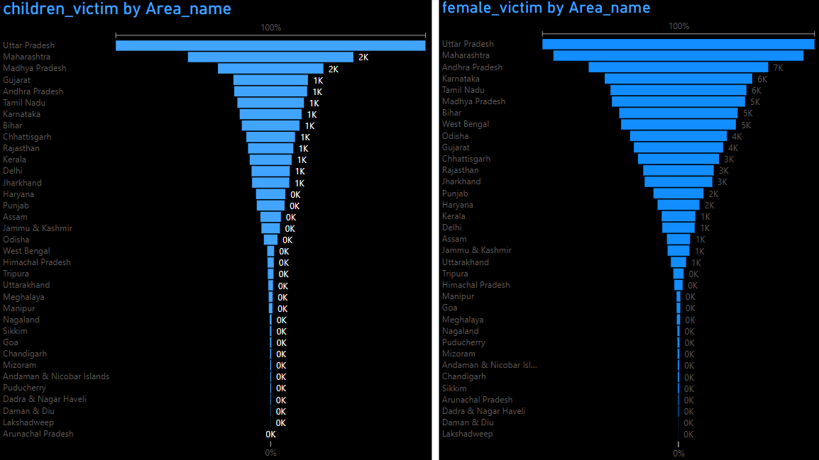

Observations:- in this we have consider childrens to all who are below 18 which includes both male and female. And in female data everyone in the data who belongs to female category are taken no matter children or adult. We found out that in both the cases uttar Pradesh and maharastra are at the top.

5.Age groupwise murder victim?

SELECT Area_Name , Sub_Group_Name , sum(Victims_Upto_10_Yrs) as below_10 , sum(victims_upto_10_15_yrs) as v_10_15 , sum(victims_upto_15_18_yrs) as v_15_18 ,

sum(Victims_Upto_18_30_Yrs) as v_18_30 , sum(Victims_Upto_30_50_yrs) as v_30_50 , sum(Victims_above_50_yrs) as above_50 FROM "Murder_victim"

WHERE Sub_Group_Name like "3. Total"

GROUP by Area_Name , Sub_Group_Name

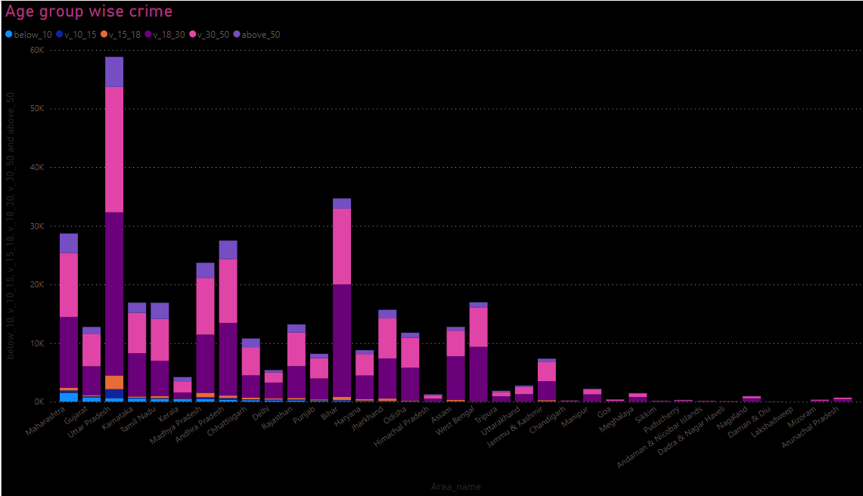

Observations:- in this data uttar Pradesh and bihar are at the top in which there are more victims of age group between 18 to 30 and at the second victims of group between 30 to 50. Also we conclude from this data that offenders also are from same age group.

6.Crime by place of occurrence?

SELECT STATE , (RESIDENTIAL_PREMISES_Burglary + RESIDENTIAL_PREMISES_Dacoity + RESIDENTIAL_PREMISES_Robbery + RESIDENTIAL_PREMISES_Theft) as residential_crime ,

(HIGHWAYS_Burglary + HIGHWAYS_Dacoity + HIGHWAYS_Robbery + HIGHWAYS_Theft) as highway_crime ,

(RIVERandSEA_Burglary + RIVERandSEA_Dacoity + RIVERandSEA_Robbery + RIVERandSEA_Theft) as riverandsea_crime ,

(RAILWAYS_Burglary + RAILWAYS_Dacoity + RAILWAYS_Robbery + RAILWAYS_Theft) as railways_crime ,

(COMMERCIAL_ESTABLISHMENTS_Burglary + COMMERCIAL_ESTABLISHMENTS_Dacoity + COMMERCIAL_ESTABLISHMENTS_Robbery + COMMERCIAL_ESTABLISHMENTS_Theft) as commercial_establishments_crime ,

(BANKS_Burglary + BANKS_Dacoity + BANKS_Robbery + BANKS_Theft) as banks_crime ,

(OTHER_PLACES_Burglary + OTHER_PLACES_Dacoity + OTHER_PLACES_Robbery + OTHER_PLACES_Theft) as other_places_crime

FROM "Crime2001_2012"

UNION ALL

SELECT STATE , (RESIDENTIAL_PREMISES_Burglary + RESIDENTIAL_PREMISES_Dacoity + RESIDENTIAL_PREMISES_Robbery + RESIDENTIAL_PREMISES_Theft) as residential_crime ,

(HIGHWAYS_Burglary + HIGHWAYS_Dacoity + HIGHWAYS_Robbery + HIGHWAYS_Theft) as highway_crime ,

(RIVERandSEA_Burglary + RIVERandSEA_Dacoity + RIVERandSEA_Robbery + RIVERandSEA_Theft) as riverandsea_crime ,

(RAILWAYS_Burglary + RAILWAYS_Dacoity + RAILWAYS_Robbery + RAILWAYS_Theft) as railways_crime ,

(COMMERCIAL_ESTABLISHMENTS_Burglary + COMMERCIAL_ESTABLISHMENTS_Dacoity + COMMERCIAL_ESTABLISHMENTS_Robbery + COMMERCIAL_ESTABLISHMENTS_Theft) as commercial_establishments_crime ,

(BANKS_Burglary + BANKS_Dacoity + BANKS_Robbery + BANKS_Theft) as banks_crime ,

(OTHER_PLACES_Burglary + OTHER_PLACES_Dacoity + OTHER_PLACES_Robbery + OTHER_PLACES_Theft) as other_places_crime

FROM "Crime2013"

UNION ALL

SELECT STATE , (Residence_Burglary_Cases_reported + Residence_Dacoity_Cases_reported + Residence_Robbery_Cases_reported + Residence_Theft_Cases_reported) as residence_crime ,

(Highways_Burglary_Casesreported + Highways_Dacoity_Casesreported + Highways_Robbery_Casesreported + Highways_Theft_Casesreported) as highway_crime ,

(RiverOrSea_Burglary_Casesreported + RiverOrSea_Dacoity_Casesreported + RiverOrSea_Robbery_Casesreported + RiverOrSea_Theft_Casesreported) as riverorsea_crime ,

(Railways_Burglary_Casesreported + Railways_Dacoity_Casesreported + Railways_Robbery_Casesreported + Railways_Theft_Casesreported) as railways_crime ,

(CommEst_Burglary_Casesreported + CommEst_Dacoity_Casesreported + CommEst_Robbery_Casesreported + CommEst_Theft_Casesreported) as COMMERCIAL_ESTABLISHMENTS_crime ,

(Bank_Burglary_Casesreported + Bank_Dacoity_Casesreported + Bank_Robbery_Casesreported + Bank_Theft_Casesreported) as banks_crime ,

(OtherPlaces_Burglary_Casesreported + OtherPlaces_Dacoity_Casesreported + OtherPlaces_Robbery_Casesreported + OtherPlaces_Theft_Casesreported) as other_places_crime

FROM "Crime2014"

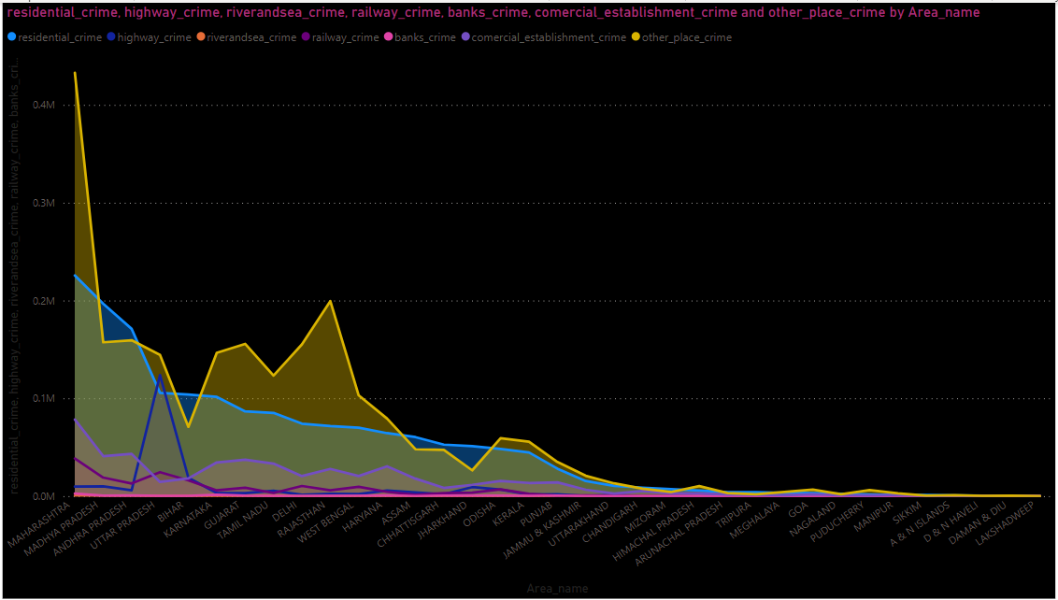

Observation:- between years 2001 to 2012 in most top affected areas most of the cases happened in the coloumn category name from other places and residential areas.

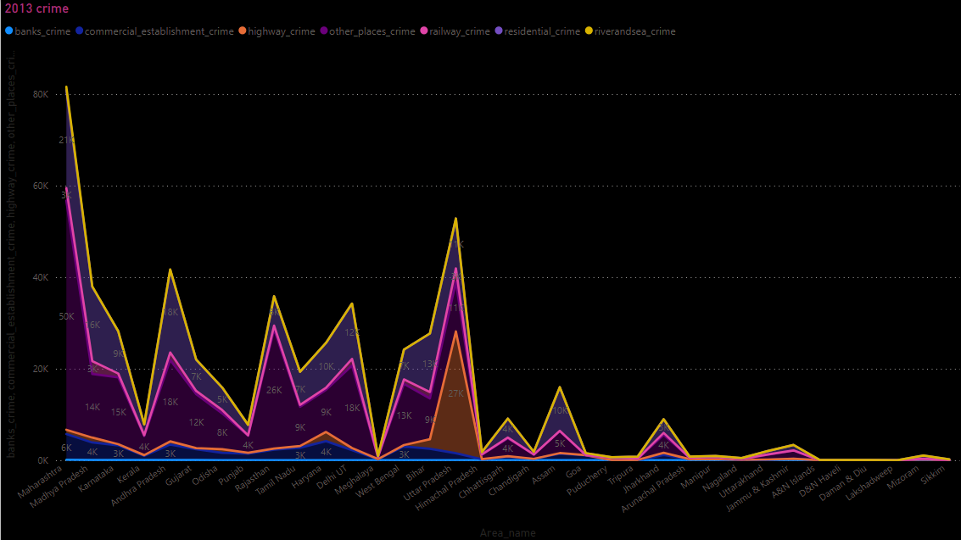

Observation :- in 2013 year data maharastra is at the top and most of the criminal activities took place in river and sea area and in banks there are very less criminal activities took place.

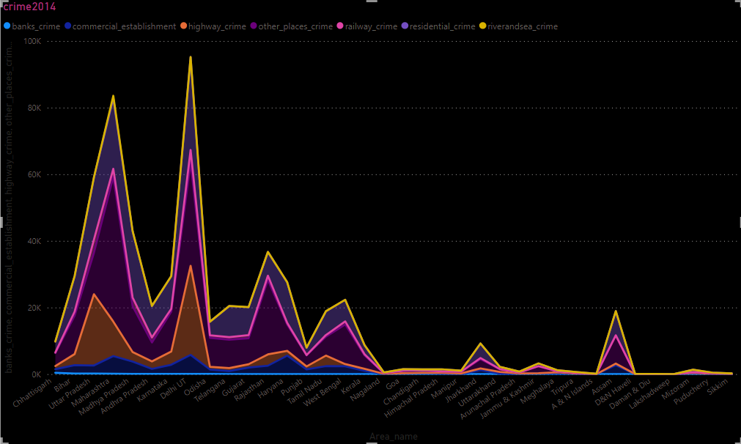

observation: in 2014 year data more number of crimes are taking place near river ands sea area and second number crimes are done in banks

from 2001 to 2014 bank crimes are continuously increasing.

7.Anti corruption cases vs arrests?

SELECT Area_Name , Year , (AC01_No_of_cases_pending_investigation_from_previous_year + AC02_No_of_cases_registered_during_the_year+

AC03_Total_No_of_cases_for_investigation_during_the_year + AC04_No_of_cases_investigated_during_the_year + AC05_No_of_cases_not_investigatedor_in_which_investigation_was_dropped_due_to_any_reason_during_the_year +

AC06_No_of_cases_transferred_to_local_police_during_the_year + AC07_No_of_cases_declared_false_mistake_of_fact_or_of_law_or_non_cognizable_or_civil_in_nature +

AC08_No_of_cases_in_which_charge_sheets_were_laid_during_the_year + AC09_No_of_cases_pending_departmental_sanction_for_prosecution_during_the_year +

AC10_No_of_cases_sent_up_for_trial_and_also_reported_for_departmental_action_during_the_year + AC11_No_of_cases_reported_for_regular_departmental_action_during_the_year +

AC12_No_of_cases_reported_for_suitable_action_during_the_year + AC13_No_of_cases_in_which_charge_sheets_were_not_laid_but_final_report_submitted_during_the_year +

AC14_No_of_cases_pending_investigation_at_the_end_of_the_year + AC15_No_of_cases_resulted_in_recoveries_or_seizures_during_the_year +

AC18_No_of_cases_pending_trial_from_the_previous_year + AC19_No_of_cases_sent_up_for_trial_during_the_year + AC20_Total_No_of_cases_for_trial_during_the_year +

AC21_No_of_cases_withdrawn_or_other_wise_disposed_off_on_account_of_death_of_the_accused_during_the_year +

AC22_No_of_cases_in_which_trials_were_completed_during_the_year + AC23_No_of_cases_convicted_during_the_year + AC24_No_of_cases_acquitted_or_discharged_during_the_year +

AC25_No_of_cases_pending_trial_at_the_end_of_the_year) as total_cases , (SELECT (ACA01_No_of_persons_in_custody_or_on_bail_during_the_stage_of_investigation_at_the_beginning_of_the_year +

ACA02_No_of_persons_arrested_during_the_year + ACA04_No_of_persons_in_custody_or_on_bail_during_the_stage_of_investigation_at_the_end_of_the_year +

ACA05_No_of_persons_in_whose_cases_charge_sheets_were_laid_during_the_year + ACA06_No_of_persons_under_trial_at_the_beginning_of_the_year +

ACA07_Total_No_of_persons_under_trial_during_the_year + ACA08_No_of_persons_whose_cases_were_withdrawn_or_otherwise_disposed_off_during_the_year +

ACA09_No_of_persons_in_custody_or_on_bail_during_the_stage_of_trial_at_the_end_of_the_year + ACA10_No_of_persons_in_whose_cases_trials_were_completed_during_the_year +

ACA11_No_of_persons_convicted_during_the_year + ACA12_No_of_persons_acquitted_during_the_year + ACA13_Percentage_of_persons_convicted_to_total_persons_in_whose_cases_trials_were_completed_during_the_year +

ACA14_No_of_persons_involved_in_the_cases_reported_for_Regular_Departmental_Action_during_the_year + ACA15_No_of_persons_involved_in_the_cases_reported_for_suitable_action_during_the_year +

ACA16_No_of_persons_punished_departmentally_during_the_year + ACA161_No_of_persons_dismissed_from_Service_during_the_year + ACA162_No_of_persons_removed_from_service_during_the_year +

ACA163_No_of_persons_awarded_other_major_punishments_during_the_year + ACA164_No_of_persons_awarded_minor_punishments_during_the_year +

ACA171_No_of_Group_A_Officers_out_of_above + ACA172_No_of_Group_B_Officers_out_of_above + ACA19_No_of_private_persons_involved_during_the_year) as total_arrested FROM "corruption_arrests" WHERE corruprion_cases.Area_Name = corruption_arrests.Area_Name) as arrested_total FROM "corruprion_cases"

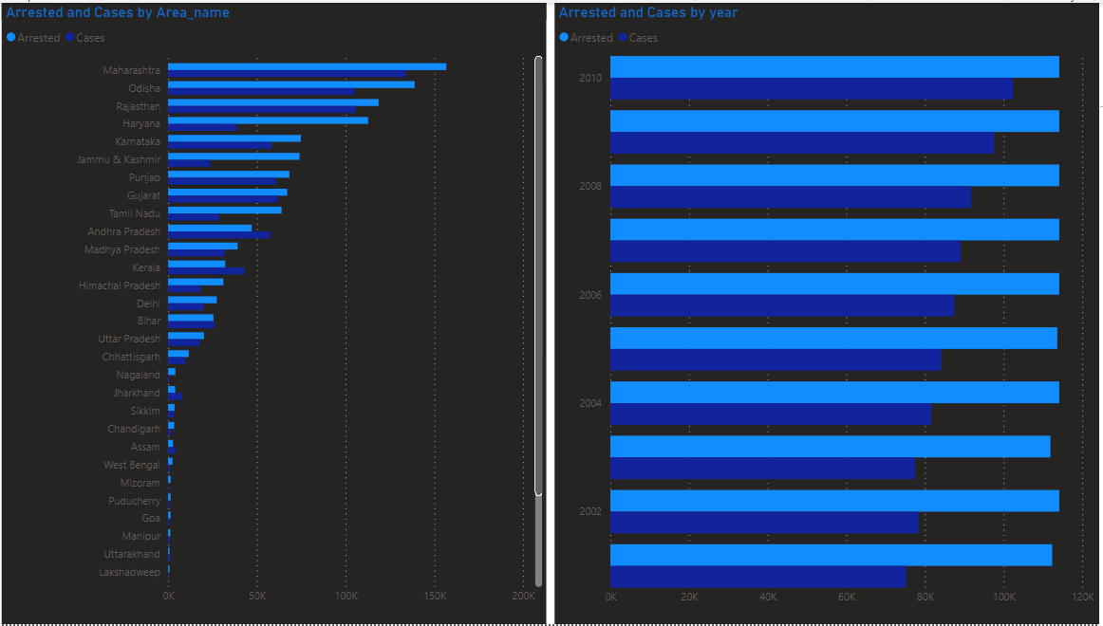

Observation :- in this we have worked on two data one is by area and other is by year and in both the cases we found out that the arrests are more than cases being done so we concluded that most of the culprits are caught red handed in corruption rather than first cases done and after investigation.

8.Which state has more number of complaints against police?

SELECT Area_Name , sum(CPA_Cases_Registered) AS TOTAL_CASES_AGAINST_POLICE FROM "25_Complaints_against_police"

GROUP BY Area_Name

ORDER BY TOTAL_CASES_AGAINST_POLICE DESC

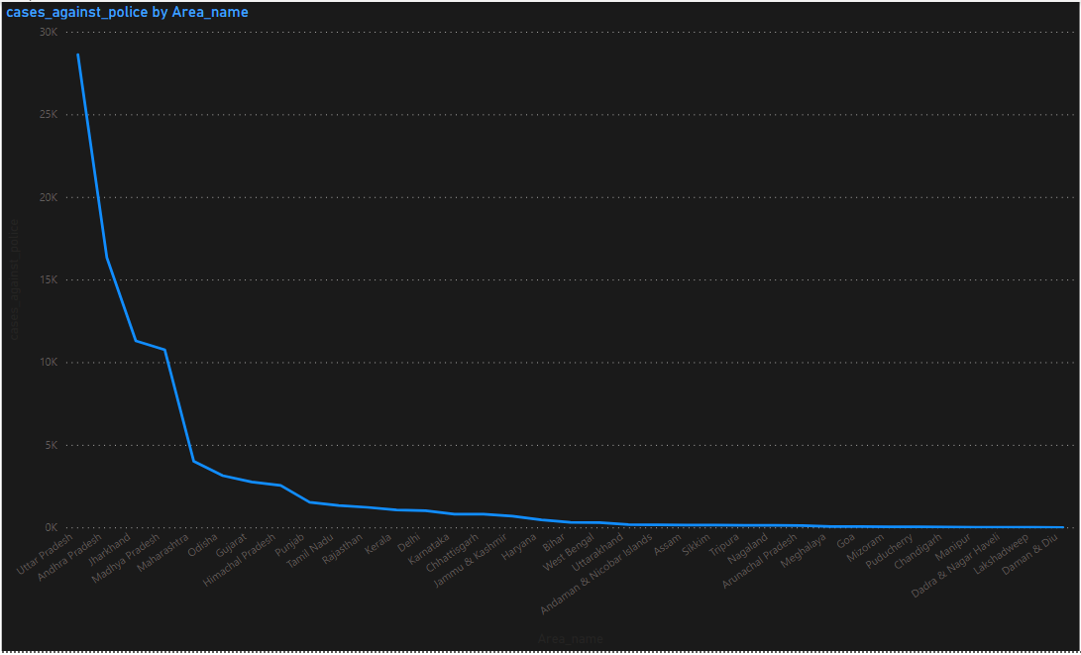

Observation:- cases against police are more done in uttar Pradesh as it the place where more criminal activies take place.

9.Which is the safest for foreigners?

SELECT Area_Name , Sub_Group_Name , sum(victims_total) as murder_victims FROM "Murder_victim"

WHERE Sub_Group_Name like "3. Total"

GROUP by Area_Name , Sub_Group_Name

ORDER by murder_victims ASC

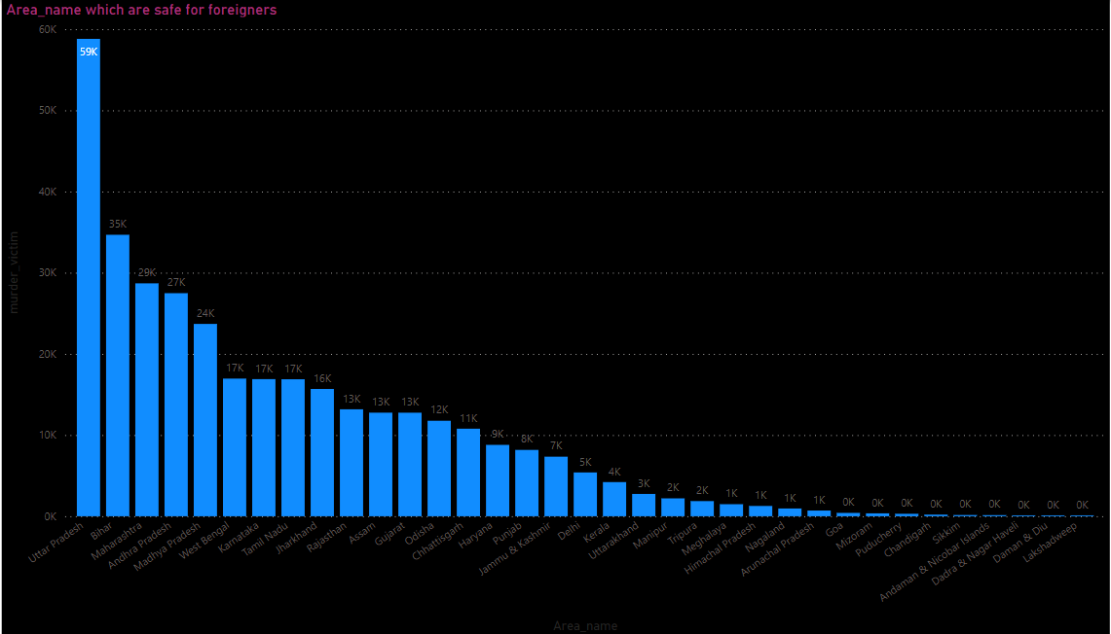

Observation:- in this we worked in the data of murder victim data and we got that lakshdeep and daman are most safest area for foreigner as there muder rate is almost zero or very less as compare to other sates.

Final conclusion is that uttar Pradesh and maharastra are the states where all kind of criminal activities are taking place in very large amount because of the population it has and also due to less implemention punishment and laws.

THANK YOU